Attendees:
- Sheyna Wisdom, AOOS
- Katrina Hoffman, Chair
- Amy Holman, Vice Chair
- Steve White, Secretary
- Dee Williams, Treasurer

Agenda
- Admin
- Upcoming Conferences - are we missing any?
- Alaska Native Board seats
- Award Update
- IRA Proposal Update

Discussion
- Administrative
  - Hourly hire of Joni Kitmiiq Speiss
  - Sheyna contract renewal
    - Contract for period of Jan 1, 2021 - Dec 31, 2023 with salary of $150,280
    - Request renewal of contract for period of Jan 1, 2024 - Dec 31, 2026 (see attached draft renewal agreement)
    - Request raise of 4.5% to $154,960. This was included in the year 3 core budget. 4.5% based on recommendation from ASLC for all AOOS staff.
      - approved!
    - performance review - March 2024
    - Discussion:
      - Fix the following in rate renewal agreement: Fix start date Jan 1, 2024; remove probationary.
      - Sheyna will send performance review/goals sheet to EXCOM
      - we can modify if we want for my role
  - Thomas review on Oct 24
  - Alice review is due in Dec
  - Other staff issues
    - Grant training: Managing Federal Grants and Cooperative Agreements for Recipients
- Upcoming conferences
  - PICES in Seattle Oct 23-26 (Jill in person, Carol virtual)
  - Cook Inlet Water Quality Summit in ANC Oct 24-25 (Thomas in person)
  - USCG Arctic & Subarctic Area Meeting Oct 25 ( Sheyna in person)
  - AK Geosummit in ANC Oct 25-27 (no one attending, sponsored two Indigenous travelers)
    - Discussion on how this came about (from ROP Steering committee)
  - Sitka Whale Fest in Sitka Nov 3-5 (Sheyna & Alice in person)
  - International Conference on HABs in Japan Nov 5-12 (Thomas in person)
  - Pacific Marine Expo in Seattle Nov 8 (Darcy in person)
  - CERF conference in Portland Nov 15-17 (Sheyna in person)
  - IOOS fall meeting in San Diego NOv 28-Dec 2 (Sheyna & Katrina? in person)
  - Alaska Municipal League Conference in ANC Nov 6-8 (booth)
  - Alaska Bird Conference in ANC Dec 11-14 (booth)
  - AEWC meeting in ANC Dec 13-15 (Sheyna in person)
  - Nov 7-9 Gulf Watch ANC (Carol)
- Alaska Native Board seats
  - meeting set with Mike, Martin, Darcy, Alice, Sheyna on Oct 27
- Award Update
  - Old agreement – Dec 2023 progress report due, working on final report
  - New agreement – Jan 2024 progress report due
  - Core funding – all subawards/contracts executed
  - Non-core funding
    - submitted 9/20/23 to IOOS
    - once new Grants system comes back on board on Oct 30, IOOS will provide review
    - We have already received funding, just waiting on approval to issue subawards/contracts
- IRA Update
  - Topic Area 1 (RA direct funds)
    - RFA received Sep 29 - $5M total
    - Posted on AOOS website: https://aoos.org/request-for-coastal-resilience-project-ideas/
    - RFI due Oct 30 - getting good interest
    - Extended this request for ideas to Nov 10
      - General timeline:
      - receive mar 4, to aslc feb 4, proposals by jan 5, notify people by late nov/early dec
    - Good meetings with several Tribal members from YK region during AFN
    - Discussion:
      - DOI gravel to gravel initiative - Dee says this a slow, generic process so nothing specific has been generated at this time. We try to leverage and share where this opportunity to activate available funds.
      - FEMA Merbok report
      - how do we coordinate/leverage/dovetail:
      - poll with the Board to see who is interested in helping us decide from who we want full proposals
  - Topic Area 2 (pan-regional projects)
    - meeting with IOOS groups to discuss how we are submitting
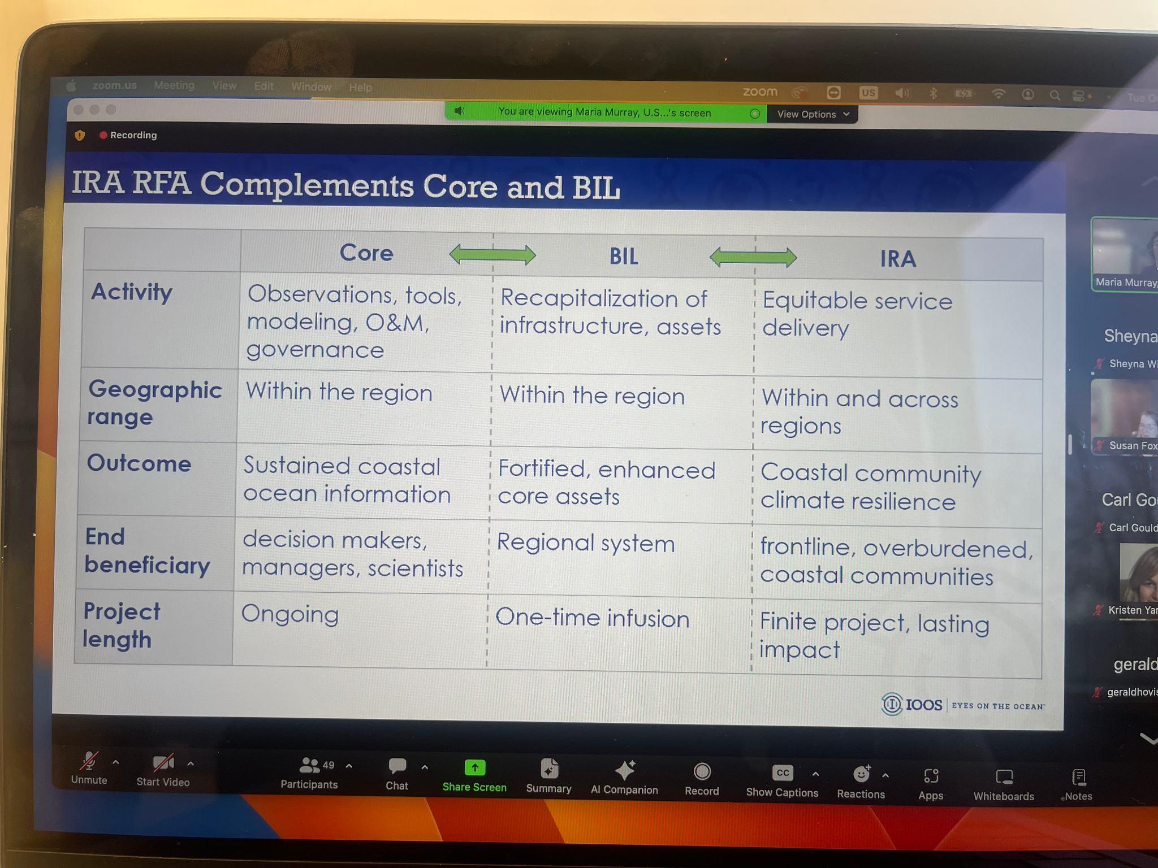
    - “Current” thought is that each RA will get $3.9M but each can decide how it is spent for the projects we’ve identified for the national scale (water levels, wave buoys, ecosystem)

