Dissolved Inorganic Carbon Sample Collection Protocol
for Citizen Science Monitors
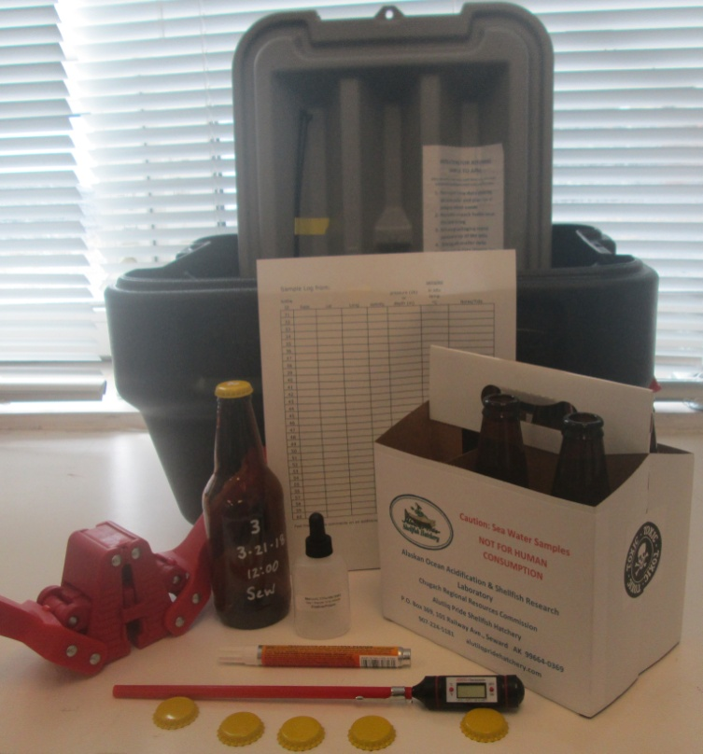
Your seawater sampling kit contains:
- Bottles & 6 pack holder
- Caps & capper
- NIST certified thermometer
- Paint pen
- Fixative & MSDS
- Sample log sheet
- Sample protocol (this sheet)
- Action Packer® with instructions for returning the samples and ziptie closures
Sample protocol: 1 sample/week with 1 triplicate sample/month. Same locale and day/time if possible.
- Label the bottle(s) with the date, bottle # and location using the paint pen ahead of time and allow to dry.
- Using a 5 gallon bucket, grab ~3 gallons saltwater from your site.
- Triple rinse the sample bottle in the sample water and dispose of the rinse water.
- Carefully fill the bottle with sample water leaving a short ~1/2" head space to allow for the cold seawater to expand after capping.
- Turn thermometer on and set to °C and place into bottle, wait until the temperature stabilizes and then log it on the data sheet.
- Log the date and locale on the data sheet as well as any comments.
- Immediately spike the sample with one drop of fixative (please read the MSDS for Mercuric Chloride included in your kit). Since this is a saturated solution it should always have a precipitate at the bottom that will not go into solution, that is normal. A clean drop of fixative without the sediment at the bottom is ideal.
- Cap bottle: place bottle in secure spot insert cap into capper, a magnet on the capper should hold the cap in place. Place onto bottle and press down firmly on the capper arms. Inspect for proper capping and then invert the sample bottle a few times. Check for leaks. If no leaks are visible, the sample should now be shelf stable at room temperature.
The samples can be stored in the Action Packer® until all the bottles are used and then the action packer with the samples and log can be returned to the Ocean Acidification lab at APSH. We will provide a method of shipping that suits your location if the USPS is not an option. Pack your Action Packer with the packaging material it came with seal and weigh the package. E-mail Jacqueline with the weight and a prepaid mailing label will be produced and emailed to you.
Any questions? Contact Jacqueline Ramsay at jacqueline@alutiiqpridehatchery.com
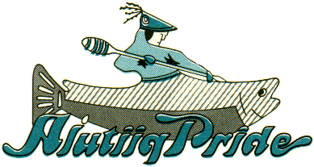Alaska Ocean Acidification and Shellfish Research Laboratory
Alutiiq Pride Shellfish Hatchery, PO Box 369, 101 Railway Ave.
Seward, AK 99664, 907-224-5181 alutiiqpridehatchery.com
A division of the Chugach Regional Resources Commission

