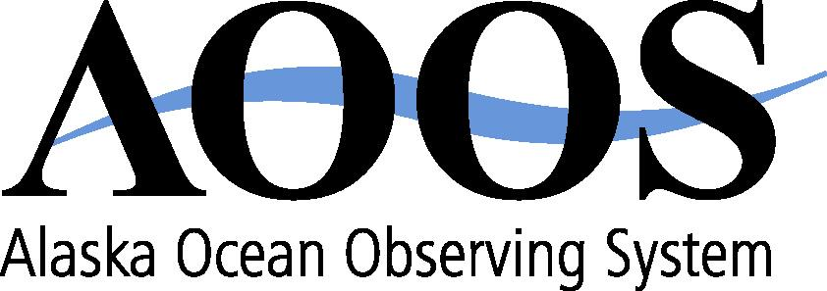
1007 W. Third Avenue, Suite 100
Anchorage, AK 99501
907.644.6703 www.aoos.org
AOOS Board Meeting
December 16, 2019
Meeting Summary Prepared by Holly Kent

Board members present: Ginny Eckert (AK Sea Grant), Steve Masterman (ADNR), Brent Goodrum (ADNR), Katherine Howard (ADF&G), Jim Kendall (BOEM), Brad Moran (UAF), Betsy Baker (NPRB), Katrina Hoffman (PWSSC), Cheryl Rosa (USARC), Ed Page (MXAK), , Bob Foy (NOAA/AFSC), Amy Holman (NOAA), Margaret Williams (WWF), Mike Miller (IPCOMM)
Board members present by phone for all or part of meeting: Theresa Peterson (NPFMC), Chip Arnold (ASLC)
AOOS staff present: Molly McCammon, Carol Janzen, Holly Kent, Darcy Dugan
Guests present: Seth Danielson (UAF)
Guests present by phone: Josie Quintrell (IOOSAssoc), Wiley Evans (Hakai), Kari Lanphier (SEATOR), Rosie Masui (KBNERR), Kathi Lefebvre (NOAA)
Meeting called to order at 9:00 am at the AOOS Conference room in Anchorage by AOOS Board Chair Katrina Hoffman.
Adoption of Agenda
Action Item: Draft meeting agenda approved unanimously. Motion by Page, second by Moran.
Adoption of Board Meeting Summary
Action Item: The board meeting summary from the July 19, 2019 executive committee approved unanimously. Motion by Baker, second by Moran.
Update on AOOS activities by AOOS Executive Director Molly McCammon
Molly McCammon provided an overview of recent and upcoming AOOS activities and participation in state, national and international level initiatives.
Alaska Activities:
- AMSS: AOOS staff on organizing team
- McCammon participating in Alaska Sea Grant structural review
- Activities of AK Harmful Algal Bloom Network, AK OA Network, AK Water Level Watch, and AK Coastal Mapping strategy
- New funding received by AOOS: more for HF radars in Bering Strait; new funds for glider program
- New funding: Bering Strait Response data sharing for decision-making
- AFE: sessions planned on microplastics, HABs, OA, Bering Sea response
National/International Activities:
- McCammon is IARPC Environmental Intelligence Collaboration Team co-lead
- McCammon on NOAA Science Advisory Board – Ecosystem Services Management Working Group; most recent report on “New technologies to support fishery stock assessments”
- Janzen presented at National Geospatial Intelligence Agency, MDA
- McCammon participating in White House Summit, UN Decade of Ocean Science planning, IOOS Grand Challenges
- OceanObs’19: emphasis on stakeholder engagement and societal needs; white papers submitted by Janzen and McCammon; special session on Arctic

Upcoming Activities:
- IOOS Advisory committee: will meet Feb 11-12 in DC
- Ocean Studies Board: planning for workshop on sustaining ocean observations; McCammon on planning commitee
- Plans for Arctic Observing Summit in late March 2020
Update on IOOS Association activities by Josie Quintrell, Executive Director, IOOS Association
Quintrell gave an overview of the IOOS Association’s efforts on past, current, and future appropriations; the FY21 Fill the Gaps Campaign; reauthorization of the ICOOS Act; planning for FY21-25; the 20 year anniversary of the IOOS program; the UN Decade of Ocean Science; the recent White House Science and Technology Summit; and IOOS challenges for the next decade.
Discussion on AOOS priorities and goals for the next decade. McCammon described upcoming plans for developing the next 5-year proposal for the AOOS cooperative agreement with NOAA IOOS, which will serve as the next AOOS strategic plan. She reviewed the priorities included in the current strategic plan and identified upcoming outreach activities at the Alaska Marine Science Symposium and the Alaska Forum on the Environment. Marine debris (including microplastics), harmful algal bloom response in the arctic and ecological forecasting are emerging issues. Board members also identified the following opportunities and issues: blue economy; resilience; partnerships with industry and philanthropy; mapping; ocean health for subsistence and fishing communities; better predictions; cruise ships/tourism; creating new state oceanographer position.
AOOS Budget Revisions
Carol Janzen gave a presentation on proposed changes to a previously board-approved project spending $50,000 on installations of new AIS/Weather stations.
Action Item: Consideration of alternate installation sites in both Bering and Chukchi Seas was approved unanimously. Motion by Holman, second by Margaret Williams.
Executive Session
The board and Executive Director held a brief executive session to discuss the proposed AOOS Executive Director transition. A search committee made up of Amy Holman, Jim Kendall, Ed Page, Margaret Williams, and a state representative (likely ADNR) was created.
Program Briefings
Presentations were given on these AOOS programs:
- AK Water Level Watch & Coastal Mapping by Carol Janzen
- OA Network & OA ferry by Darcy Dugan
- HABs Regional Update by Rosie Masui (KBNERR), Kari Lanphier (SEATOR), and Kathi Lefebvre (NOAA)
- Bering Sea research focus, regional collaboration team by Molly McCammon and Cheryl Rosa
- Ecosystem & Climate trends: ships, gliders, radars & ecosystem moorings by Seth Danielson (UAF)
- AOOS Data Center: New Products & Capabilities by Rob Bochenek
Planning for FY 21-25
Presentations were given and followed by discussion on:
- Future of AOOS Data Management Advisory Committee by Carol Janzen, which will be voted on by board at spring 2020 meeting. The board also discussed the contract with Axiom Data Science for AOOS data management and recommended it be extended for an additional year.
- Process for reviewing current & new projects by Carol Janzen
- Stakeholder engagement by Molly McCammon
Ocean Observing Roundtable
Board members and guests shared current news and upcoming events.
The meeting adjourned at 5:00pm. Motion to adjourn by Margaret Williams, second by Holman.

