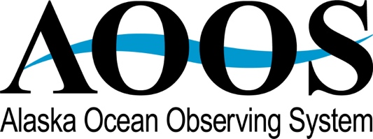

February 2019 Monthly Update

HIGHLIGHTS

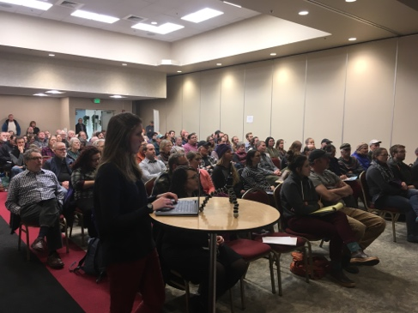
OA Briefing in Juneau - On February 20, the Alaska Ocean Acidification Network held a public presentation and Q&A session in Juneau, facilitated by Darcy Dugan. Bob Foy, director of NOAA AFSC and Jessica Cross, oceanographer with NOAA PMEL, provided updates on the on ocean conditions and species response to a packed audience of 100 people. More people joined through the Facebook Live event organized for this presentation. Participants asked excellent questions and the Q&A went on for 40 minutes. You can see the recorded presentation at https://aoos.org/alaska-ocean-acidification-network/ If you are interested in an ocean acidification presentation to your organization or community, please email Darcy Dugan at Dugan@AOOS.org.

While in Juneau, Darcy, Jessica and Bob also presented to the United Fishermen of Alaska, talked to reporters, and did a brief radio segment on KTOO.

CONFERENCES/MEETINGS
2019 AFE – AOOS presented an informational booth during the 2019 Alaska Forum on the Environment highlighting the Alaska Ocean Acidification network and the Alaska Harmful Algal Bloom Network. The event was well attended by many Alaskans from rural communities with lots of questions on both AOOS efforts.
HAB workshop at AFE Feb 15 – The Alaska Harmful Algal Bloom Network (AHAB) held its first workshop since forming in 2017 concurrent with the Alaska Forum on the Environment on February 16. The workshop was very well attended with over 50 members attending for updates on statewide HABs research, a demonstration of the AHAB data portal, and a revitalization of working groups on Communications and Outreach; Research; Event Response; and Monitoring. Breakout session were held in the afternoon to set priorities for the upcoming year.
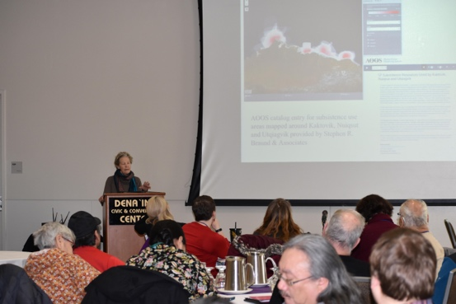
Sea Grant oil spill workshop Feb 20-21 – Molly presented on the two AIS decision support products that AOOS developed during a panel on “How to Prepare Communities for the next Technological Disaster.” The panel was part of a larger workshop entitled “Setting Priorities for Health, Social and Economic Disruptions from Spills in Alaska: Learning from the Past, Preparing for the Future’. It was sponsored by Sea Grant and funded by the National Academy of Sciences’ Gulf Research Program.

Mapping & Surveying conference Feb 13-15 – Marta Kumle attended the Alaska Survey and Mapping Conference in Anchorage, AK on February 13-15, 2019. Conference attendees include survey, mapping and GIS professionals throughout the state. This yearly conference provides a venue for courses, panel discussions, presentations and networking in the geospatial fields. Marta joined experts from government and private industry in a panel discussion titled: Life After Statewide Digital Mapping Initiative: Deciding the Next Big Data Layer for Alaska. The discussion focused on current status of mapping data in Alaska and future priorities, including coastal and wetlands mapping. Marta also presented an update on the Coastal Mapping Strategic Plan including the coastal data grading system and the recently launched Coastal Mapping Prioritization Survey.
ADMINISTRATIVE
Meetings in Juneau – Molly met with a number of AOOS board members in Juneau February 19 to discuss current activities and future products. She met with Ed Page and other staff of Marine Exchange of Alaska to discuss future AIS/weather sites and AIS data management needs. She met with Bob Foy and Elizabeth Siddon at NOAA to talk about ways to add value to NOAA’s ecosystem status reports. And finally, she met with US Coast Guard board member Paul Webb and with Captain John Hollingsworth, Chief, Incident Management Branch 17th District, and Rear Admiral Matthew Bell, about use of AOOS data by the district. We also discussed creating an annual training session for Coast Guard staff, since there is so much turnover.
NWS meeting – Molly meets every 2 months with senior staff at the National Weather Service’s regional offices in Anchorage. The most recent meeting was February 20. She reported on the status of our water level efforts, and NWS reported on the status of their integrated services center (now official).

IOOS
ICOOS Act reintroduced – HR 1314 – “To reauthorize the Integrated Coastal and Ocean Observation System Act of 2009” was reintroduced in the House Feb 20 with Alaska Rep. Don Young as sponsor, and Oregon Rep. Suzanne Bonamici as cosponsor. The Senate version should be introduced soon.

PROJECT HIGHLIGHTS

Western Alaska Storm Models PI meeting Feb 1 – AOOS hosted a project PI meeting during the week of AMSS for the IOOS OTT modeling project: Building Coupled Storm Surge and Wave Operational Forecasting Capacity for Western

Alaska (Short title: Western Alaska Storm Models). In this project, a multiscale, multi-process integrally coupled wave-surge forecast modeling system will be refined and validated with a focus on transition to operations while resolving key

issues that presently limit forecast reliability in western Alaska. AOOS and Axiom are providing data management support for this project, and with PIs developed a model-input data manifest for the project during the meeting. Carol and Rob (Axiom) attended.

HFR outreach – Molly, Carol and board member Amy Holman met by phone Feb 22 with the UAF High Frequency Radar team (Seth Danielson, Hank Statscewich and Rachel Potter) to discuss plans for deploying the radars (funded in last year’s budget) this spring. Since this is a major investment and commitment, the team is looking at areas that are technically and logistically feasible, and hope to deploy the radars in May or June (depending on snow) on a test basis before committing to the final sites.

DATA MANAGEMENT
Animal Telemetry Network (ATN) – Carol, Rob and Stacey (Axiom) continue to host bi-weekly calls with the ATN Data Assembly Center coordinators Bill Woodward (IOOS) and Michael Wiese (US Navy) on the development of the ATN Website/Data Portal. May 1 is the expected release date of the publicly available ATN data portal.
Axiom Presentations - Axiom participated in the Alaska HAB Network Workshop on February 11, 2019 to demonstrate the Alaska Shellfish and HAB Data Portal and discuss opportunities to improve and scale the data portal to additional Alaska regions. Axiom also participated in the Cook Inlet Regional Citizens Advisory Council’s Geographic Resource Information Database (GRID) technical workshop on February 22, 2019 to beta test the user interface in the Cook Inlet Response Tool portal and to discuss future revisions and implementation of the tool.
Based on feedback from users at the GRID workshop, AOOS recently added an additional base layer to the Ocean Data Explorer. FAA Sectional Aeronautical Charts are the primary navigational reference for visual navigation of slow to medium speed aircraft, and they will be an additional resource for pilots that use the AOOS real-time sensor map for trip planning. Users can adjust the base layers under ‘Settings’ in the upper right toolbar.

UPCOMING EVENTS

Mar 4-6 Japan - U.S. Arctic Science Collaboration: Reflections on the Past 2 Decades and Future Opportunities (Carol)

Mar 13-15 Consortium for Ocean Leadership public policy forum & spring meeting, WA DC (Molly)

Mar 19-21 IOOS Program spring meeting WA DC (Molly & Katrina Hoffman)

Mar 21-22 IOOS Federal Advisory Committee, WA DC (Molly)

Apr 11-12 Arctic Domain Awareness Center (UAA) Annual Meeting, WA DC (Carol)

Molly, Carol, Holly, Darcy, Kayla, and Stacey

