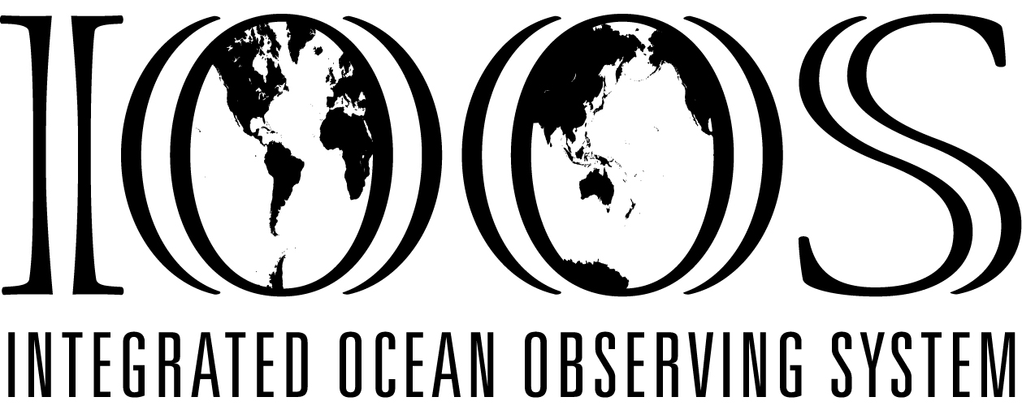
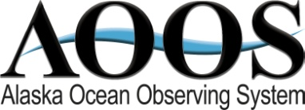
www.aoos.org www.ioos.gov
AOOS in the ARCTIC
Goals
- Increase ocean & coastal observations in the U.S. Arctic; fill gaps
- Make Arctic data more accessible and useful
- Develop information products for stakeholders & decision-makers

Focus Areas
- Improve safety of marine operations
- Track climate and ecosystem trends
- Mitigate coastal hazards
- Monitor water quality

AOOS Supported Observations
- High frequency radars – monitor ocean surface currents in the Chukchi and Beaufort Seas to be used for oil spill trajectories and ecosystem modeling
- Ocean acidification – maintain an OA buoy network making continuous OA measurements on moorings in Bering Sea and Gulf of Alaska
- Distributed biological observatory – support international collaboration to monitor physical, chemical and biological parameters at stations in Bering Sea and Strait, Chukchi and Beaufort Seas to detect change over time
- Glider observations – support underwater glider missions to simultaneously record marine mammal calls and oceanographic conditions in Chukchi Sea biological hotspots
- Northeast Chukchi Sea mooring – establish year-round measurements of 23 physical, chemical, geological, and biological parameters
- Beaufort Sea wave measurements – support bottom-mounted acoustic wave & current meters to better understand year-round nearshore currents.
- Water levels – support short-term measurements to use in storm surge and coastal hazard planning

Data & Information Products
- Research Assets Map – interactive map describing past, current and future assets & research programs in Arctic, used primarily for research and operational planning
- Arctic Portal – regional version of the AOOS Ocean Data Explorer combining real-time, model forecasts and remote sensing, GIS, and project level data into single system for multiple displays & applications
- Digital Sea Ice Atlas – provides historical & climatological sea ice information dating back to 1850s for all Alaska coastal waters
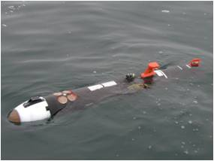
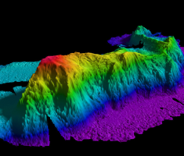
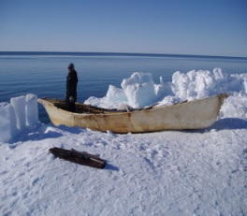
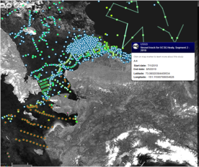
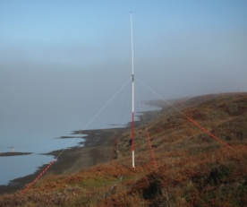
- Research Workspace collaborative – provides secure cloud-based data sharing system to promote scientific data sharing & integration; used by the North Pacific Research Board, BOEM, RUSALCA project and now hosting oil and gas industry data collected in the Chukchi and provided through a NOAA-industry data sharing agreement
- Climate projections – downscale climate models to provide wind, sea ice & sea surface air temperature projections for Alaska coastal waters

Projects in Progress or Under Development
- Arctic ERMA collaboration – coordinating AOOS Ocean Data Explorer with NOAA’s Emergency Response Management Application to avoid duplication and expand data access and tools
- Automatic Identification System – piloting the addition of marine weather forecasts to AIS systems for future use in Arctic
- Coastal Hazards – building a collaborative to increase wave and storm surge measurements and maps to protect local communities
- Technology test bed - exploring use of Kasitsna Bay Lab for testing applications of underwater technology for use in Arctic
- Tagged animal network – integrating data from sensors on marine mammals used to collect ocean data and relate habitat use and migratory patterns of tracked animals to ocean conditions

Policy & Management Collaborations
International: Sustained Arctic Observing Network, Circumpolar Biodiversity Monitoring Program

National: US Arctic Observing Network, Ocean Research Advisory Panel (member), Integrated Arctic Research and Policy Committee (implementation teams), Integrated Ocean Observing System Association (executive committee)

State & regional: AK Climate Change Executive Roundtable, AK Center for Climate Assessment & Policy (steering committee), AK Data Integration Working Group (member), NOAA Regional Collaboration Team, Cooperative Institute for Alaska Research (fellow), AK Sea Grant Program (advisory committee), North Pacific Research Board, North Slope Science Initiative

Contacts
Molly McCammon Darcy Dugan Rob Bochenek Ellen Tyler
AOOS Executive Director AOOS Program Manager AOOS Data Manager AOOS Program Coordinator
mccammon@aoos.org dugan@aoos.org rob@axiomalaska.com tyler@aoos.org
(907) 644-6703 (907) 644-6718 (907) 230-0304 (907) 644-6715
