Sea Ice User Information Survey

--- Results ---

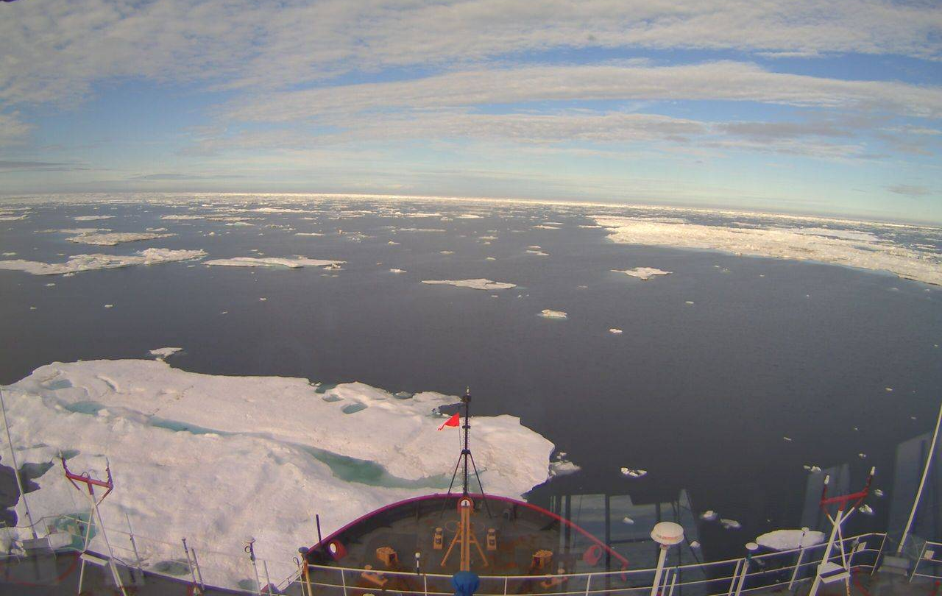
Ice floes from the bridge of the Healy in August, 2012 near Barrow. Photo courtesy of the US Coast Guard.

August 2013

Alaska Ocean Observing System
Alaska Center for Climate Assessment and Policy
National Oceanic and Atmospheric Administration

Table of Contents

Background……………….……………….……………….……………….………………….. 2
Participation……………….……………….……………….……………….…………..……. 3
Results by Entity
National Ice Center……………….……………….……………….……………. 5
National Weather Service Ice Desk……………….……………….……… 8
NASA……………….……………….……………….……………….………………… 11
National Center for Environmental Prediction………………………. 14
National Snow & Ice Data Center……………….……………….………… 16
Geographic Information Network of Alaska……………….…………. 19
Ocean and Sea Ice Satellite Application Facility……….……………. 21
Barrow Area Information Database…………….……………….……….. 23
UAF Observations at Barrow…………….……………….……………….…. 24
SEARCH Sea Ice Outlook for Walrus…………….……………….………… 26
Additional sea ice websites identified by respondents……………………… 28

Background
On behalf of a number of sea ice product developers, the Alaska Ocean Observing System circulated a survey on sea ice data products to people who access online sources for sea ice information. The information collected from this study is intended to help sea ice providers better understand their audience and guide the development of future sea ice resources, including a historic sea ice atlas through the University of Alaska Fairbanks.
The survey was circulated via email in June and July of 2013. It took approximately 10 minutes to complete, and asked about the sea ice products people used, how often, and for what purposes. The survey was developed in partnership with the Alaska Center for Climate Assessment and Policy (ACCAP) and NOAA.

The responses to open ended questions are included verbatim from the survey, but are not matched with the name or affiliation of the participant. We hope this will assist sea ice developers as they refine existing products and develop new ones.

If you have questions about the survey or results, please email Darcy Dugan at dugan@aoos.org

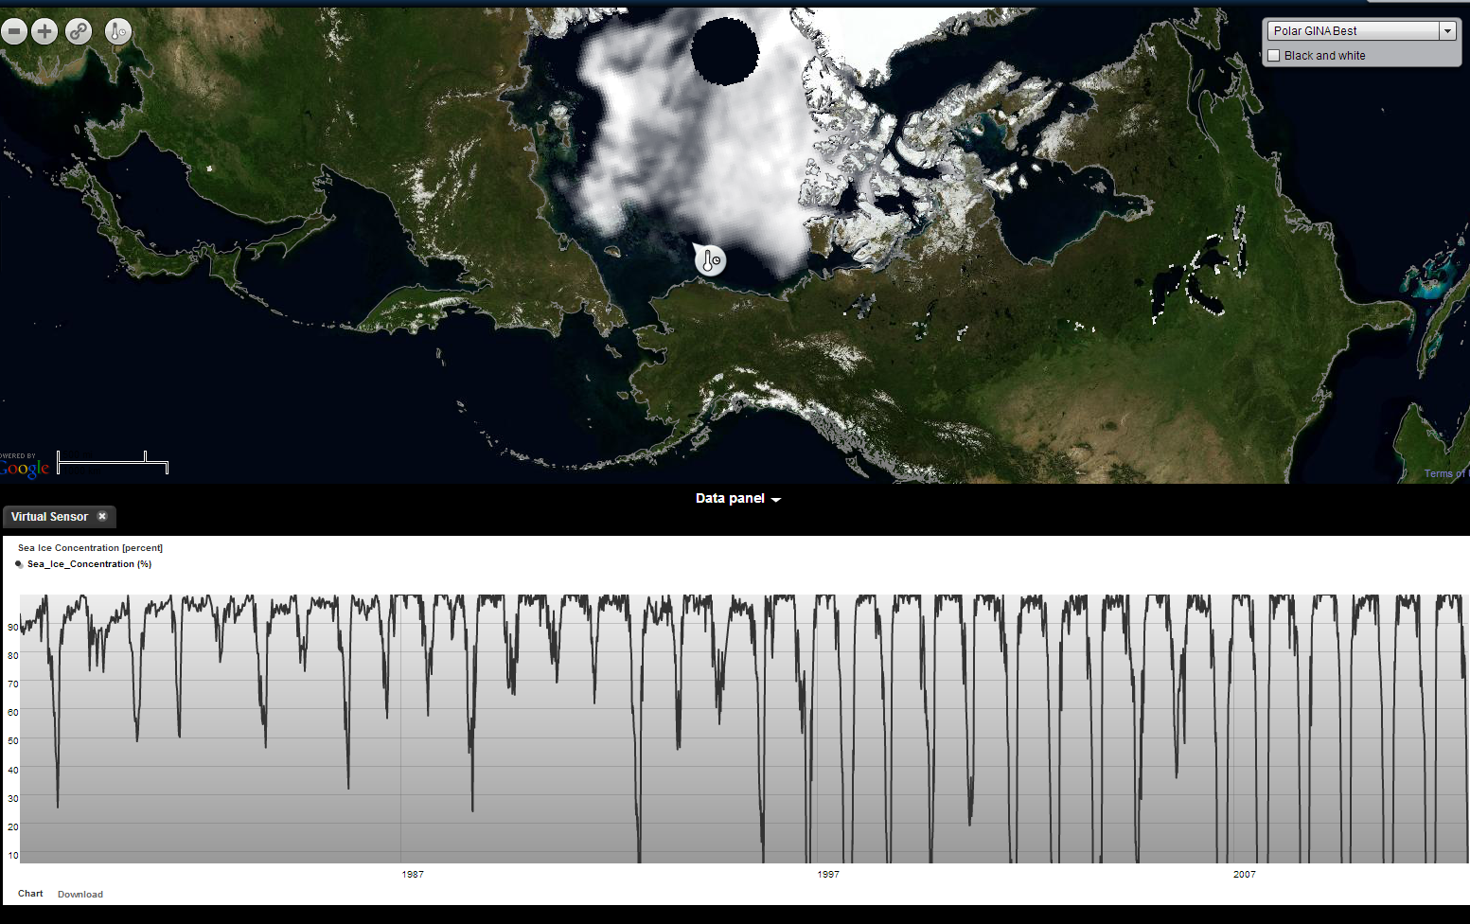
Sea ice extent and thickness from the NSIDC viewed in the AOOS Arctic Portal

Participation

The survey was distributed by list serves subscribed to by sea ice information providers, members of the North Slope Borough and Northwest Arctic Borough, Arctic researchers that took part in the Alaska Marine Science Symposium, contributors to the Arctic Research Assets map, the IARPC sea ice working group, military contacts, members of the shipping and fishing industries, and others. Those who received the survey were asked to forward it to other relevant colleagues.

113 participants took the survey. 88 provided their affiliations, listed below:

Organization and Role (as reported)

Agency (23 respondents)

- Alaska Dept Fish & Game, Wildlife Biologist (2)
- BOEM Oceanographer (2)
- NOAA Corps/NOAA Ship Fairweather
- Maritime Safety and Security lLb - Germany
- NASA Space Center, Oceanographer
- National Ice Center
- NOAA - Ice Analyst
- NOAA NWS, Officer in Charge; Barrow
- NOAA Senior Analyst/Forecaster
- NOAA Ship Oscar Dyson
- NOAA Hydrographer
- NOAA Research Biologist
- NOAA Polar Ecosystems/NMML Wildlife Biologist
- USFWS, Supervisory Wildlife Biologist,
- US Army Corps CRREL & Brown University
- USCG District 17 (dpw)
- USCG Operations Analyst
- USCG SPAR, commanding Officer
- USGS Alaska Science Center
- USGS Wildlife Biologist (2)

Academic (27 respondents)
- Alaska SeaLife Center
- Arctic and Antarctic Research Institute – Russia. Leading scientist
- Arctic Research Consortium of the US (ARCUS)
- Arctic Research Consortium of the US (ARCUS) - Executive Coordinator
- Bigelow Laboratory for Ocean Science - Senior research scientist
- Cambridge, UK - Prof of Ocean Physics
- Clarkson College - Professor
- Dartmouth College - Professor
- European Center for Medium Range Weather Forecasting (ECMWF) - Scientist
- European Center for Medium Range Weather Forecasting (ECMWF) - Senior scientist
- National Snow & Ice Data Center (2)
- National Snow & Ice Data Center - NOAA Liaison
- National Snow & Ice Data Center - Postdoctoral research fellow
- University of Alaska Fairbanks
- University of Alaska Fairbanks Assistant Professor
- University of Alaska Fairbanks SMC, Marine Superintendent
- University of Alaska Fairbanks-Marine Advisory Program, Bering Strait agent
- University of Alaska Fairbanks-Research Assistant Professor
- University of Delaware - Research Associate Professor
- University of Iceland, Institute of Earth Sciences
- University of TX Austin - Res Associate Prof
- University of Washington
- University of Washington, Oceanographer
- University of Washington Applied Physics Lab - Senior Principal Oceanographer
- University of Washington Polar Science Center, Applied Physics Lab
- University of Washington, PhD student

Military (12 respondents)

- Arctic Capability Analyst
- Arctic Submarine Laboratory/N3
- Chief of Arctic Planning
- Deputy for Navy Policy and Posture
- Fleet Weather Center, Norfolk Operations Officer
- Naval Postgraduate School
- Naval Postgraduate School - Assistant Research Prof
- Naval Postgraduate School - Research Professor
- Naval Research Laboratory
- Office of Naval Research Global - Associate Director
- US Naval Academy Polar Science Program
- US Naval War College - Oceanography

Private (10 respondents)
- Norseman Maritime
- Charters - General Manager
- Exploration Operations Advisor
- Captain/Mate
- Lewellen Arctic Research, Inc.
- Engineer/consultant
- ArcticTurn (contractor)
- Research Biologist, SAIC
- Michael Baker Engineers - Arctic Engineer
- Shell Ice and Weather Advisory Center - Lead Ice Analyst
- ABR, Inc - Senior Scientist

Local (5 respondents)

- Port of Nome - Retiring Harbormaster
- Bethel Port Director
- Kotzebue Environmental Specialist
- St. George Delta Fuel
- Native Affairs/Natural Resources Adv

Results by Entity

National Ice Center (NIC)
http://www.natice.noaa.gov/

“How do you use current daily and weekly products of sea ice concentration, extent, and type from the NIC and for what purpose?”

- To supplement info that I get from the NWS Ice Desk
- To assess rate of ice development
- Track ice movement for first barge arrivals in the spring to determine access routes. Used only during breakup and freeze up periods to determine impact to operations.
- Usually in the spring to gauge if the ice downriver is going to jam up.
- Used for classes at US Naval Academy.
- High Winds and Seas Products, Graphical Weather Forecast and Optimum Track Ship Routing Forecasts.
- I'm an Arctic Operations Specialist. We use the SPAROSLANT and PAC products for MIZ locations and FLAP for locating surfaceable features
- Navigational planning.
- Track the marginal ice zone and >8/10ths ice coverage areas.
- Navigation for Research Vessel Norseman II
- I go out on the ice to fish mostly every day.
- Research (4 people entered this)
- Research; cruise preparation
- I use the MASIE KMZ files and plug them into Google Earth, or just use the charts they've already generated. I use this to build briefs on the Arctic with the most relevant information. Our operations department uses it on a daily basis.
- Briefing local disaster coordinator's office, Search and Rescue, and whaling captains on conditions and expected changes.
- Planning and supporting US Navy operations in the Arctic.
- I analyze the U.S. National Ice Center, as well as use previous products for continuity.
- Climate change impacts & predicted changes.
- Operational decisions for marine and ice road support of offshore petroleum operations in the Harrison Bay - Colville River delta area
- Find out the number when I needed
- For validation of Arctic and Antarctic research institute sea ice model
- Forecast model input & validation
- Geld campaign design, research
- I browse through it once or twice a year.
- Personal interest
- General knowledge of ice conditions
- Mapping of ice edge relative to wildlife telemetry locations
- To compare with satellite images in the Greenland Sea
- The Navy uses the daily ice edge location for model verification/validation.
- I develop software for NIC as a contractor
- For selecting study sites when writing a proposal, and then later for trying to select specific sites when in the field.
- Ice movements and concentrations for Arctic, Bering Sea, Cook Inlet, and North Slope, vessel movements
- I use this product for monitoring where the sea ice is going. I would like them to offer ECTIS overlay. They claim that they offer this but do not have the correct projection to use with NOAA charts.
- One of the basic updates on Arctic sea ice cover, comparison with other observational and model-derived products
- To look at area of coverage.
- Products are accessed and used prior to our research ship operations in or near the Bering Sea ice edge.
- Automated download and processing.
- Utilized during Opilio and herring season to determine vessel navigation options and departure possibilities. Generally on a daily basis from December through June
- Plan seafloor clearance surveys. General engineering planning.
- Pipeline safety in Beaufort Sea
- Hunting
- Watching the rate of sea ice growth and melt to include particular focus on the max and min levels in March/Sept.
- Used them for patrolling in the Arctic on a non ice-rated vessel.
- To access shape files of ice types.
- Model Validation and Verification
- Currently I access NIC for ice information to stay abreast of current situations for general information. Within the next year I expect to access NIC daily for ice information associated with SIKULIAQ operations.
- Producing shapefiles for annual report to give an idea of what the summer-fall ice conditions were, and to compare ice coverage from one year to the next.
- Determining ice concentration and ice edge values to use as covariates for habitat modeling of seal and walrus locations.
- Primarily for examining sea ice habitat use by polar bears and walruses, and sometimes for field logistics.
- Physical oceanography research
- During planning for Arctic Deployments
- Sea ice concentration data for comparing with model output and other observations
- Used primarily to resolve differences in ice types and concentrations between NOAA, NIC and Canadian ice analysis.
- To support modeling efforts
- Research purposes. Looking at climatic trends
- Irregularly, I check the NIC site for detailed analyses that include ice type. I also appreciate and sometimes use the MIZ product to check how other products are doing in comparison. I sometimes use them to answer questions from the press or NSIDC colleagues, but usually as "truth" to validate remote sensing products against.
- Operational needs and scientific analysis.
- Check status of melting of sea ice in Chukchi Sea
- Mission planning, rough analysis and graphics
- Time series analyses.
- Aerial survey planning in the NE Chukchi and western Beaufort Sea; weather data archiving; mapping in GIS when/if shapefiles are available
- Quick summary to cross-validate
- Various
- I extract mean ice concentration around acoustic moorings to correlate ice with marine mammal occurrence
- Situational awareness for ship operations and monitoring ice conditions that affect navigation.
- Looking at landfast ice, percentage of different ice types in a given area by year, average climatology of sea ice over long periods
- I use them for mapping purposes. I overlay the positions of marine mammals with sea ice for planning purposes and publications.
- To better understand marine based subsistence opportunities as well as predict/understand habitat conditions for marine wildlife
- Upload and integrate spatial data into internal database

National Weather Service (NWS) Ice Desk
http://pafc.arh.noaa.gov/ice.php

“How do you use information from the National Weather Service Ice Desk and for what purpose?”
- I used to access them daily as a vessel agent, however now I'm using them to develop and plan for operating in Cook Inlet in the winter for an oil company. I also use the reporting to maintain a general awareness of conditions around Alaska.
- Assist in field work
- Track ice movement for first barge arrivals in the spring to determine access routes. Used only breakup and freeze up periods to determine impact to operations.
- Optimum Track Ship Routing Forecasts, safety of navigation.
- For route planning for ship navigation.
- For operations in the Chukchi and Beaufort Sea
- I use them to plot areas that would give me the most fishing opportunities.
- Checking conditions in the region to help with project support needs.
- Same as above, to build briefs.
- Briefing local disaster coordinator's office, Search and Rescue, deep water shipping companies, and whaling captains on conditions and expected changes.
- Planning and supporting US Navy operations in the Arctic.
- Access when analyzing the U.S. National Ice Center Alaska Region Charts.
- Climate change impacts & predicted changes.
- Operational decisions for marine and ice road support of offshore petroleum operations in the Harrison Bay - Colville River delta area
- Check ice conditions
- For validation of model
- Forecast model input & comparison
- It's more like a couple of times a week for the sea ice forecasts, which I review as part of the ARCUS Sea Ice for Walrus Outlook.
- For Sea Ice Outlook and Sea Ice for Walrus Outlook (during the summer)
- See if its growing and how it compares to other years
- General knowledge of ice conditions
- Have used these once in the past but would like to use more often for model validation.
- Regional analyses
- To relate animal locations to ice coverage.
- Used while operating in or near the sea ice edge.
- I access daily via Kathleen Cole's website during seasons when we have field operations.
- Utilized during Opilio and herring season to determine vessel navigation options and departure possibilities. Generally on a daily basis from December through June
- Plan for arctic operations for seafloor clearance surveys. Daily checks during the March through October timeframe.
- to check as to approximately where the ice is at
- Research
- Check spring ice conditions.
- Track sea ice dynamics in relation to walrus migrations and predicting use of coastal haul outs.
- Used to estimate the nature of sea ice with respect to shipping current use and future activity estimates.
- While operating in the Arctic these were used on a daily basis for safety of ship navigation decisions.
- For SA, This is for the Anchorage Ice Desk.
- Model V&V
- For now as general information on trends. In the future as an aid for SIKULIAQ operations.
- Part of assessing what sea conditions might be like prior to conducting aerial surveys for marine mammals
- For visualizing the location and concentration of sea ice ot guide our seal and walrus tagging projects.
- Primarily for field logistics.
- Used for browsing current conditions to keep informed.
- Planning for transits during winter months
- I infrequently look at the analyses to compare with gridded data sets of sea ice concentration and if an unusual event is happening.
- Once again the selection should have allowed for a weekly choice selection due to the frequency with which the chart is produced. Daily not an option for sea ice analysis as cgart frequency is not done a daily basis. SST analysis is only once a week during winter season and increases to twice a week during the summer. Ice analysis charts are not used during the summer due to lack of information on partial for ice types and lack of continuity with other ice centers in depicting decay of ice. NOAA ice charts continue to run against the grain of current charts from NIC and CIS by having new and young ice appearing on their charts during the melt out.
- Research, Improvement of own planned TerraSAR Sea Ice Service
- (Frequency is variable) As with NIC products above, but I assume these might have better info for AK, so check these if looking at that area.
- aerial survey planning in the NE Chukchi and western Beaufort Sea; weather data archiving; mapping in GIS when/if shapefiles are available
- Daily preceding and during the open-water season to assess conditions for field work
- planning SZRS flights
- 5 day forecasts are used in some areas (Bristol Bay & Arctic) to plan the timing of USCG buoy tender deployments to install seasonal aids to navigation.
- We use the 5-day forecasts for study planning and occasionally for mapping. We collaborate with oceanographers to examine sea surface temp to identify upwelling, but we do not do this weekly.
- In particular, I am interested in SST and how it might affect the distribution of disease, in particular Vibrio parahemolyticus. It would be helpful if the coverage for Alaska had better resolution. Also, I look at images to get a feel for animals might be and for planning field projects.
- I use the "regular" sea ice maps not the 5 day forecast - you do not have this listed as an option - also - the satellite images have good ice images as well.
- Mostly on a weekly basis

NASA – MODIS imagery
https://earthdata.nasa.gov/data/near-real-time-data/rapid-response

How often do you “MODIS rapid response near real time imagery” from NASA and for what purpose?

- Will add it to my toolbox to use.
- Seasonal change in ice cover
- Track ice movement for first barge arrivals in the spring to determine access routes. Used only breakup and freeze up periods to determine impact to operations.
- If the MODIS product doesn't come in for us I go to the web and get it from there.
- As needed to track Arctic and other weather events.
- Navigation and Science projects
- Various project needs
- Research
- Though I think MODIS is plugged into MASIE
- Briefing local disaster coordinator's office, Search and Rescue, and whaling captains on conditions and expected changes.
- Planning and supporting US Navy operations in the Arctic.
- I use the LANCE website to obtain additional imagery on a regular basis.
- Climate change impacts & predicted changes.
- Visual imagery to assess model input/output
- Research
- For Sea Ice Outlook and Sea Ice for Walrus Outlook (during the summer)
- Keeping up to date on ice coverage
- Mapping of ice edge relative to wildlife telemetry locations
- Import geotif files to ArcGIS program to compare with other satellite imagery and in situ data to analyze ice extent, ice concentration and distinguish clouds from ice.
- We have used MODIS imagery for verification of model products.
- We have gone through the NIC special support
- Use it to get NASA imagery because the NASA product portal is not very user friendly.
- As needed for model-data synthesis
- Research
- Automated download and processing through a KML interface.
- Utilized during Opilio and herring season to determine vessel navigation options and departure possibilities. Generally on a daily basis from December through June
- Plan for arctic operations for seafloor clearance surveys. Daily checks during the March through October timeframe. Also, occasional checks off-season for general engineering interest.
- Research
- Too hard to load on my computer
- Check for the amount of sea ice habitat.
- Not used due to my position as a research funding agency representative and not a field or operational researcher.
- To assess what conditions are like near Barrow and along the North Slope
- I anticipate using it more in the future.
- I download and add the MODIS images weekly to use as the background layers (ice data) for movement maps of satellite tagged seals and walruses. I also use these images for visualizing the location and concentration of sea ice ot guide our seal and walrus tagging projects.
- Assessing movements and habitat conditions for numerous species that we track with satellite telemetry.
- Used in production of Sea Ice analysis and download is 250 m resolution. It is checked almost daily but some areas are not downloaded if cloud covered.
- Research on Oil spill, Cloud Imagery for storm assessment, investigation of sea state variability due to wind gustiness
- Research
- I look at the polar mosaics every now and then, mostly if I'm alerted to something unusual going on.
- Curiosity, do far.
- Maybe a few times/summer
- mission planning but daily during certain seasons (April-July)
- Illustrations of the use of satellite data.
- aerial survey planning in the NE Chukchi and western Beaufort Sea; weather data archiving; mapping in GIS when/if shapefiles are available
- Assess conditions for field work
- planning SZRS flights and providing context for ocean measurements
- To look at current sea ice conditions
- This is a great resource that we use for mapping whenever there is enough sunlight (i.e., not in the arctic in winter) and when imagery is not contaminated by cloud cover. We rely more on NIC data when good MODIS is not available.
- weekly use - but unfortunately that is not an option on your survey...
- We integrate MODIS data into our interpretations of ice conditions for the Chukchi and Beaufort. We don't access the site, but integrate the data internally

National Center for Environmental Prediction (NCEP)
http://polar.ncep.noaa.gov/seaice/Analyses.html

How often do you use “daily sea ice concentration maps developed from passive microwave satellites” from NCEP and for what purpose?
- Will add it to my toolbox to use.
- Seasonal change in ice cover
- Track ice movement for first barge arrivals in the spring to determine access routes. Used only breakup and freeze up periods to determine impact to operations.
- I only access this thing daily for fishing purposes. All other things I do not look at .
- checking conditions in the region to help with project support needs.
- Briefing local disaster coordinator's office, Search and Rescue, and whaling captains on conditions and expected changes.
- Planning and supporting US Navy operations in the Arctic.
- Rarely used
- Climate change impacts & predicted changes.
- research
- Analysis of wildlife telemetry locations use of variable ice concentrations
- Same as #3 especially when it is cloudy.
- Look at ice conditions to plan for field work
- Various analyses
- Used while operating in or near sea ice edge.
- Automated download and processing through a KML interface.
- Research
- Use NSIDC products mostly.
- I use the CFSR ice fields for wave model hindcasts
- The data part of the data we use to produce our sst and sea ice concentration 'analysis'
- I have not dealt with NCEP, my focus for sea ice has always been NIC and the Canadian Ice Service.
- We use NSIDC for SSMI-derived ice concentration maps.
- We operationally receive gridded sea ice concentration data sets which we use and compare with other operational products
- Due to the weakness of passive microwave in the summer season in classifying some areas as sea ice free when lighter concentrations of ice present 1-3/10 of belts and strips and the underestimation in some areas when ice is flooded this is not really a useful product in a tactical environment.
- General Interest
- Setup global hindcast models for WAVEWATCH3.
- Investigation of sea ice boundary to order high resolution SAR data.
- Research
- Compare to other data or use for model forcing

National Snow and Ice Data Center (NSIDC)
http://nsidc.org/

How often do you use information from NSIDC and for what purpose?
- Look at development of ice
- Track ice movement for first barge arrivals in the spring to determine access routes. Used only breakup and freeze up periods to determine impact to operations.
- Curious
- Navigation. For this reason Climatology is not that useful, it is interesting though.
- Marginal ice zone and >8/10ths ice coverage.
- I use the sea ice information to help me with my fishing endeavors. I also check them for weather patterns and how weather will be on the ice.
- research
- I use their products, aggregates of others, on a more frequent basis - since it's all nicely located in one spot.
- Briefing local disaster coordinator's office, Search and Rescue, and whaling captains on conditions and expected changes.
- Planning and supporting US Navy operations in the Arctic.
- The U.S. National Ice Center charts that are available on the NSIDC website are useless, as the resolution is severely degraded from the data that was provided to them. I use in-house data derived from the NSIDC product, that is actually rendered usable as a briefing/display tool
- Climate changes & environmontal impacts.
- I download the monthly sea ice extent data and comparing with model simulations. I am planning to use their daily analysis soon.
- For model and climate studies
- monitoring Arctic ice extent, particularly in summer
- research, keeping up to date with what the ice is doing
- Look at some pieces, again for reference with the SIWO/SIO projects.
- For keeping up with sea ice extent during summer (for Sea Ice Outlook)
- just want to know if there is more or less ice- keeping a eye on the climate out of personal intrest
- general info on ice conditions
- See the bigger picture and trend
- NSIDC is very helpful in being the warehouse of ice products/data. The monthly ice summary posted on the website is also very useful. We are currently working to convert the MASIE ice/no mask to a daily ice concentration product.
- my work is sea ice geophysics research. I look for products for my work but only on a monthly basis to find good case studies.
- one of the basic updates on Arctic sea ice conditions
- research, evaluation of current ice conditions
- I download the SSMI data daily through automated scripts.
- Use historical data for statistical prediction of sea ice in a certain area.
- Research
- Evaluate sea ice habitat for seals.
- Used for estimating the rate of climate change in the Arctic in order to a) justify the need for improved observations and basic research and b) inform policy development for the region in the DoD.
- Used for navigational information and planning while operating in the Arctic and the Bering Sea.
- General information and scientific analysis
- General background for now, more focused for SIKULIAQ operations in the future.
- To visualize ice concentration around villages to guide us in our seal and walrus tagging projects. 2. Provide Ice data for covariates in a habitat analysis of seal and walrus location data. or 3. Ice concentration data included in seal and walrus movement maps.
- Assessing polar bear and walrus sea ice habitats and sometimes for field logistics.
- I use them for research. I download the daily gridded files from NSIDC and then make my own monthly and annual climatologies and anomalies. I use browse images on occasion to answer particular questions on the fly but not for research quality publications.
- Use the news to keep up-to-date with what is happening and it provides a useful synthesis - also like using the "charctic" plotting Infrequently use data for comparing model output with observations
- Compare to own results using high resolution SAR data, to plan a useful SAR Sea Ice Service
- Research
- Comparing interannual variations, variation of ice cover for research icebreaker planning.
- Most of these fall under the NOAA funding line at NSIDC, so under the project I manage. I feel responsible for them so check them often.
- Research - model evaluation.
- Seasonally for mission planning but daily during those season (April-August). Monthly for graphics and coarse analyses. For true analyses I usually download entire seasons or years of daily data.
- Time series analyses.
- various
- Mostly used for presentations about emerging Coast Guard roles in the Arctic and trends in Arctic Shipping.
- NEPA and modeling.
- Sometimes I use this data when good MODIS images are not available.

Geographic Information Network of Alaska (GINA) – UAF
http://sv.gina.alaska.edu/

How often do you use information from Swathviewer or Puffin Feeder at GINA and for what purpose?
- Field work planning
- same reasons above
- Field work in Barrow.
- I use these things for watching the sea ice flow.
- Use the VIIRS data when analyzing the Alaska region charts.
- Access occasionally, general interest.
- For Sea Ice for Walrus Outlook (weekly reports)
- have used it to view ice data availability, but haven't found a useful way to download data of interest for personal use in GIS-based applications
- I'd like to learn more
- Wow, how can I learn more about all the data that's available?
- Use it in the springtime to monitor breakup conditions. recently it has not been working for me, so I moved to NASA images forwarded by people at NMML.
- scientific analyses
- Research
- Used frequently in the Arctic and as necessary in the Bering Sea.
- I use the SwathViewer weekly to visualize ice concentration around villages to guide us in our seal and walrus tagging projects.
- Assessing habitat conditions in relation to wildlife migrations.
- Checking ice conditions on a particular day.
- Good to know about these! In the past I've used AOOS, of course, and Barrow Ice Observatory web site.
- Swathviewer information BOEM paid for and we have in house.
- I often use the SwathViewer to locate ice images... SwathViewer is faster than loading MODIS from other sources. However, the mapping capabilities are limited and I cannot download geo-referrenced images from SwathViewer. As such, the capabilities of SwathViewer are limited

Ocean and Sea Ice Satellite Application Facility (OSI-SAF)
http://saf.met.no/p/ice/

How often do you use information from the Ocean and Sea Ice Satellite Application Facility (OSI-SAF) and for what purpose?
- Research
- I use them to help with my fishing.
- Planning and supporting US Navy operations in the Arctic.
- For validation of model and climate studies
- General interest
- Ice monitoring
- We need to take a better look at these products and see what's available.
- I'd like to learn more
- For selecting study sites
- OSI SAF data are part of the data we received blended with SST from OSTIA
- We receive the product operationally and use it for our forecasting but we take it from the OSTIA product
- To plan a high resolution SAR Sea Ice Drift product
- Every now and then I look at ice drift, just to get one more picture of what is happening.
- NEPA

Barrow Area Information Database (BAID)
http://www.baidims.org/

How often do you use sea ice information from the Barrow Area Information Database (BAID) and for what purpose?

- I only use this as a curiosity to what the ice looked like last year, compared to this year.
- For comparison of fast ice in Tiksi region
- I am interested in learning more
- Plan for arctic survey operations.
- Research
- When these were up-to-date I accessed the information weekly, but only during spring.
- I would use it in future to look at TS-X TanDEM data in comparison

University of Alaska Fairbanks – Observations at Barrow
http://seaice.alaska.edu/gi/observatories/

How often do you use information from UAF webcams and ice radar and for what purpose?
- I use them when I am bored, as I would like something to look at. I also use them to help me decide whether or not I am to fish that day.
- Research; planning field work
- Planning and supporting US Navy operations in the Arctic.
- Just to see what the sea ice is doing!
- Ice conditions
- I am interested in learning more
- I access daily when we have field operations.
- Plan for arctic survey operations.
- Research
- Used for estimating the rate of climate change in the Arctic in order to a) justify the need for improved observations and basic research and b) inform policy development for the region in the DoD.
- General information
- To fulfill my curiosity on occasion.
- I infrequently look at the ice webcam during the melt season
- Daily during meltout to verify ice analysis
- Research
- Research
- About 1x per year or maybe more frequently I'll look at one of these, again just to get one more picture of what is happening, if something noteworthy is going on .
- Aerial survey planning in the NE Chukchi and western Beaufort Sea
- I just like seeing the ice conditions off Barrow when I'm up there
- I have tried to access the Barrow webcam & radar data before online and have never had success.
- Sense of what the ice is doing in Barrow.
- I use these resources informally. I just check them to see how much open water there is during whaling season.
- I live in Bering Strait - Barrow's ice conditions are not that applicable to us. We could use the coverage for subsistence and maritime safety issues - what do we need to do to make that happen?

SEARCH Sea Ice Outlook for Walrus (SIWO)
http://www.arcus.org/search/seaiceoutlook

How often do you use information from the Sea Ice Outlook for Walrus and for what purpose?

- Quick reading
- Project Manager for the project.
- I am one of the organizers (ARCUS)
- Mostly find this interesting to look at, but don't actually use this information.
- Interesting to read.
- I should but time is limited with all the other duties and I am not a biologist or fisheries person
- For both ice conditions and information about walruses
- Curious
- I access daily during times of field operations.
- Just found this information this year and started to apply it to my knowledge base.
- Avoidance.
- To get ice and walrus updates from walrus hunters.
- Curiosity
- Keeping track of goings-on.
- Research
- This is interesting for the way it is designed, and I find it useful to read hunter's descriptions.
- Just out of curiosity
- Weekly but unfortunately that is not an option on your survey - even though these are weekly updates...

Additional sea ice websites identified by respondents

- http://wattsupwiththat.com/reference-pages/sea-ice-page/ Best single sight compilation of disparate sea-ice data on the web
- http://dynaweb.cis.ec.gc.ca/IceGraph20/page1.jsf?lang=en http://arctic.atmos.uiuc.edu/cryosphere/
- I have a vast assortment of links that I regularly use when producing U.S. National Ice Center charts. Please contact me if you need this list. thomas.holden@noaa.gov
- http://arctic.atmos.uiuc.edu/cryosphere/ check the graphs and animations on the website
- I use ice charts of AARI , you can see its at www.aari.ru
- Canadian Ice Service charts, use for comparison/validation of model forecasts and to monitor Arctic ice condition, Arctic icebergs International Ice Patrol, north Atlantic icebergs
- Bremen passive microwave products. ECMWF/NCAR-NCEP reanalysis products (even though their representation of sea ice is terrible, we use this data for forcing models).
- Ice Mass Balance Buoy data International Arctic Buoy Program Woods Hole BGEP (moored ULS)
- Icebridge data at NSIDC Global Fiducials Library access portal
- Ron Kwok's web page with RGPS data
- Polarview GlobIce AARI index of datasets www.seaice.dk
- NASA Lance ASF data http://neven1.typepad.com/blog/ ... seriously, your survey is a little missrepresentative of the wealth of information out there for sea ice sciences and the interested public to use.
- http://arctic.atmos.uiuc.edu/cryosphere/
- http://moe.met.fsu.edu/snow/
- http://nsidc.org/arcticseaicenews/
- http://ocean.dmi.dk/arctic/meant80n.uk.php all to track the arctic ice & snow
- Russian, Norwegian and Canadian ice charts
- NOAA AVHRR, MODIS, Quickscat, AMSR, SSMI, available SAR imagery (previously ENVISAT). I would be interested in seeing how Suomi NPP works for sea ice.
- Cryosphere Today ice concentrations, past IceSAT ice thickness, RGPS, ICEBridge, non-US ice extent/concentration estimates
- Ice age from Maslanik
- AMSR-2 through Uni Bremen.
- The Pribilofs
- Canadian Ice Service, Research.
- Products that I would use that don't yet exist would be forecasts for shipping through sea ice and direct comparisons with past levels of sea ice & shipping activity.
- Sea ice products from the MERCATOR system, used so far only in research mode when studying wave sea-ice interaction
- Canadian Ice Service for information north and east of Alaska. I have worked with Canadian Ice Service on numerous occasions and I like their products.
- http://www.iup.uni-bremen.de:8084/amsr2/ [superior resolution] http://manati.star.nesdis.noaa.gov/datasets/OSCATData.php [ice products; age] http://www.scp.byu.edu/SCPproducts.html {Quikscat for recent years; age] http://www.ijis.iarc.uaf.edu/seaice/data/201208/ http://ice-glaces.ec.gc.ca/App/WsvPrdCanQry.cfm?CanID=10062&Lang=eng [SAR; need better access] http://arctic.atmos.uiuc.edu/cryosphere/ [regional stats; ice area stats]
- I use satellite-based ice thickness fields from JPL to validate ice models.
- We use Piomas data as an estimate of the evolution of ice thickness/volume
- TerraSAR X Near Real time products from DLR station in Neustrelitz, mainly icebergs. Other parameters in development, like sea ice type, sea ice drift in high resolution, e.g. near shore or around platforms
- I use historical sea ice info resources in the process of trying to get more of the like on line. E.g. http://nsidc.org/data/g02203.html (Arctic Sea Ice Charts from Danish Meteorological Institute, 1893 - 1956) and http://nsidc.org/data/g02176.html (Sea Ice Charts of the Russian Arctic in Gridded Format, 1933-2006)
- We use a wealth of information from ECMWF, NASA, NCAR, NSIDC, the Arctic International Buoy Program and other source of in-situ, meteorological, oceanographic and cryospheric data for model evaluation, initial and boundary conditions for a coupled model, the focus of which is decadal forecasts of sea ice in the Arctic.
- http://arctic.atmos.uiuc.edu/cryosphere/ Other visualizations of regional ice cover for cross-validation.
- I'm with the US Coast Guard and occasionally we will conduct overflights for ice observations in areas where we suspect ice may have damaged aids to navigation.
- FAA aviation web cam websites for Wales, etc. To better understand the conditions the subsistence community as well as the marine wildlife are dealing with and also to make predictions as to the upcoming seasonal conditions

