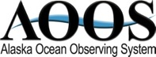
June 2015 Update

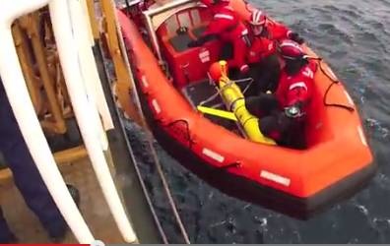
HIGHLIGHTS
AOOS 2014 Film Contest Showcase – Each week, a new short film from AOOS’ 2014 contest is being highlighted on the AOOS homepage. This week’s film is Arctic Gyres produced by David Forcucci and documents science operations and life aboard the U.S. Coast Guard Cutter Healy during a physical oceanography research cruise to the Beaufort and Chukchi Seas in 2012. Watch the film.
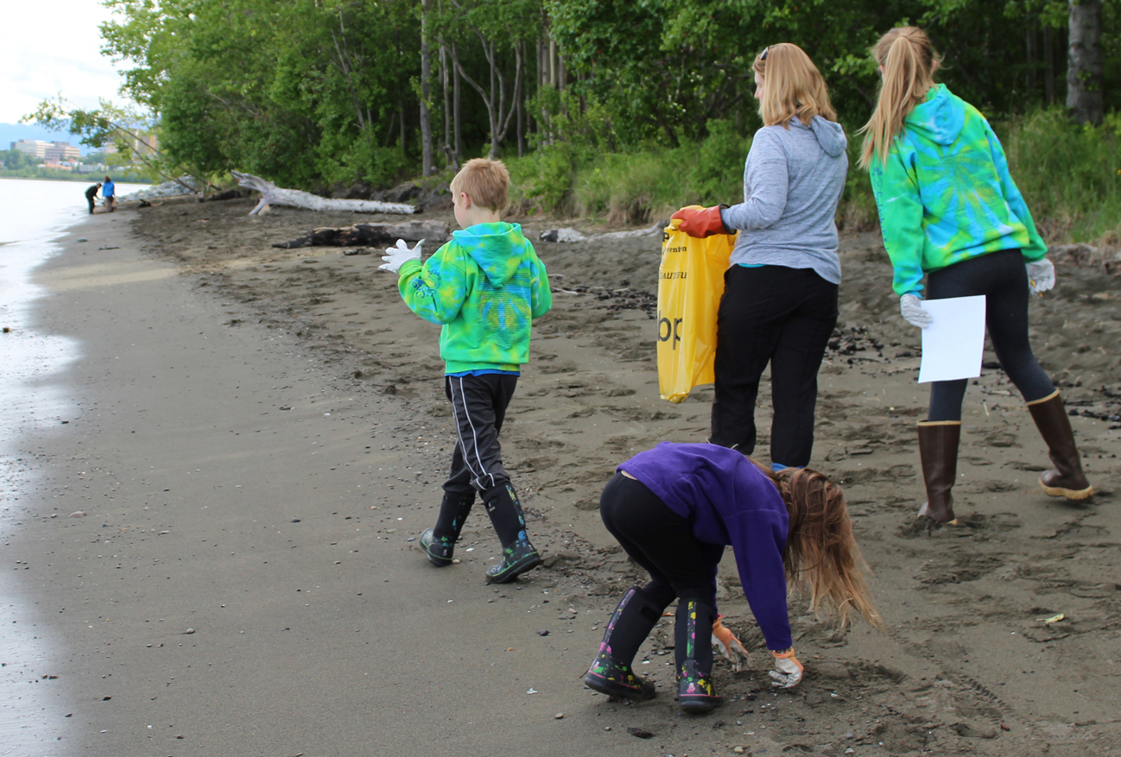
Anchorage Coastal cleanup – AOOS helped sponsor the annual Anchorage coastal cleanup June 6 and collected over 300 pounds of marine debris on 2 local beaches. The event was co-sponsored by the Alaska Marine Conservation Council. As in past years, the vast majority of trash collected was nails, cigarette butts, and glass.

Yukon Delta Chinook Timing Outlook & Forecast – The outlook for 2015 was released on June 1 through a partnership between AOOS, NOAA Fisheries, and the Alaska Department of Fish and Game.

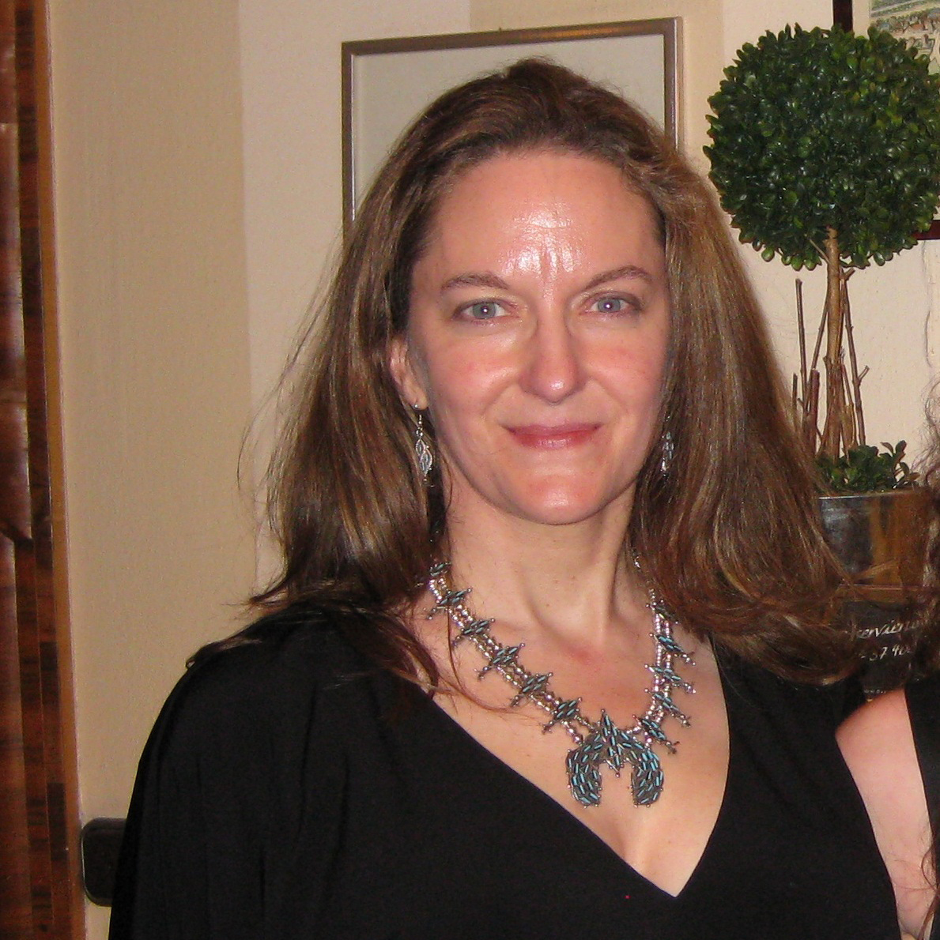
ADMINISTRATION

Welcome to Carol Janzen – Carol joins the AOOS staff this month as AOOS Operations Director. With a Ph.D. in Physical Oceanography, Carol brings more than 20 years of marine science education and experience spanning the private, public and academic sectors. Most recently with Seabird Electronics in Redmond, Washington, Carol is very knowledgeable about Alaska issues as well as those of the IOOS program, having been involved with both the Gulf of Maine Ocean Observing System and the Pacific Northwest system.
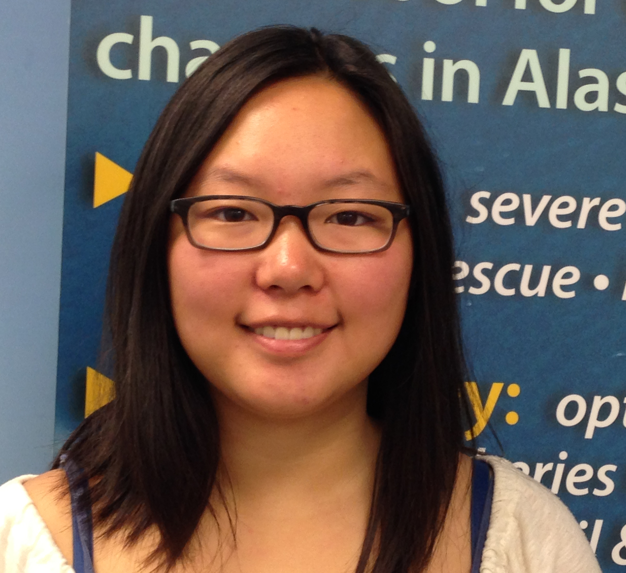

Welcome to Sijo Smith – Sijo is an Eagle River resident now attending Stanford University. She will be interning with AOOS this summer, focusing her efforts on developing communication and outreach tools on AOOS initiatives including ocean acidification and ‘the Blob’.

AOOS Board meeting – The AOOS Board met in Anchorage June 29 to review a conceptual draft of the AOOS 5-year NOAA proposal due at the end of August. The board approved the conceptual draft as presented, with a few tweaks. The board also approved funding for 2 new water level sensors to be deployed in the Beaufort Sea, as well as funding to support a new Coastal Resiliency specialist at Alaska Sea Grant.

AOOS DMAC proposal review – The AOOS Data Management Advisory Committee met informally June 25 to review and comment on the conceptual draft of the NOAA proposal.

Proposal submitted – AOOS/Axiom partnered with Agnew Beck Consulting in submitting a proposal to provide communication tools and training for Coastal Resilience and Adaptation in Alaska, in response to an RFP from the US Fish and Wildlife Service’s Landscape Conservation Cooperatives.

MEETINGS/CONFERENCES/TRAVEL
Kenai CIRT workshop – On June 5, Will Koeppen of the AOOS data team and Sue Saupe
of the Cook Inlet RCAC provided a hands-on workshop for resource managers on the Cook Inlet Response Tool (CIRT) in Kenai. The workshop was funded with a grant to AOOS from the Kenai Peninsula Fish Habitat Partnership and helped familiarize people with AOOS resources, while also collecting important feedback.

Partnership Meeting – AOOS staff met with Cook Inlet Regional Citizens Advisory Council Science Director Sue Saupe and Port of Anchorage Deputy Director Sharen Walsh and Crowley representative Greg Pavellas to discuss future observational needs in Cook Inlet and the potential for data sharing.

PRESENTATIONS
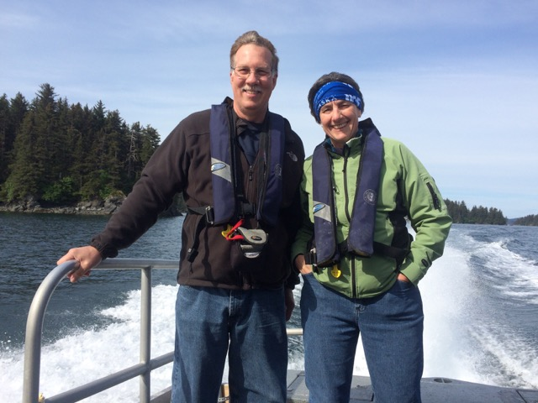
NOAA VIP visit – A number of AOOS Board members and partners joined AOOS staff in Anchorage June 9 in briefing Dr. Russell Callender, NOAA’s National Ocean Service Acting Assistant Administrator, and Vice Admiral Michael Devany, NOAA’s Deputy Under Secretary for Operations, on how ocean observing is making a difference in Alaska in regards to navigation safety, coastal hazards, and environmental intelligence.
Dr. Russell Callender & Kris Holdereid

GOING FORWARD – Some Key Upcoming 2015 Activities
July 7-10, Washington DC, IOOS briefing to Senate (Molly)
July 13-15, Geneva, WMO Year of Polar Prediction (Molly)

July 15, Alaska Marine Policy Forum – by phone
July 14-16, Washington DC, Navy Ice diminished Arctic (Carol)
July 23-24, Fairbanks, AK Arctic Observatory & Knowledge Hub planning meeting (Molly & Carol)

Molly McCammon, Darcy Dugan, Holly Kent, Carol Janzen, Sijo Smith and Rob Bochenek

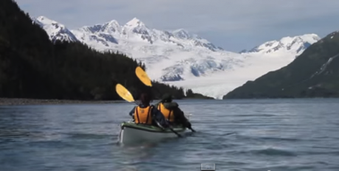

Special Note: the 2015 Film Contest is Underway – For the second year, AOOS is welcoming films under 10 minutes relating to Alaska’s oceans or coasts. Submission deadline is Sept 15, and the grand prize is $1,000. Learn more.

